**ADBMS CIA**

**DHAMINI R NIJGAL**

**2047013**

1. **Write a PL/SQL program to display 1 to 15 on screen except for 6 and 9. (using while and for loop)**

Answer:

BEGIN

FOR num in 1 .. 15 LOOP

IF(num=6) THEN

dbms_output.put_line(null);

ELSIF(num=9) THEN

dbms_output.put_line(null);

ELSE

dbms_output.put_line(num);

END IF;

END LOOP;

END;

Using both while and if loop

DECLARE

n number:= 1;

BEGIN

DBMS_OUTPUT.PUT_LINE ('The first '||n||' numbers are: ');

while (n <= 15)

LOOP

for i in n..n loop

IF(i=6) THEN

dbms_output.put_line(null);

ELSIF(i=9) THEN

dbms_output.put_line(null);

ELSE

dbms_output.put_line(i);

END IF;

END LOOP;

n:=n+1;

END LOOP;

dbms_output.new_line;

END;

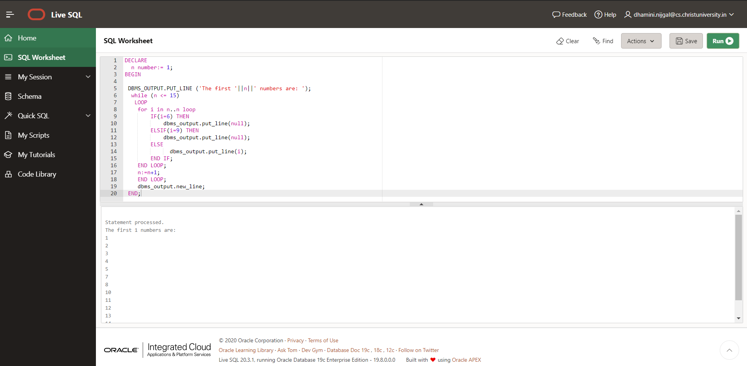

OP:

Statement processed.

The first 1 numbers are:

1

2

3

4

5

7

8

10

11

12

13

14

15

1. **Use a cursor on emp table. Take each name , extract 2nd char and display the name, the**

**2nd char and the ascii value of the same.**

create table employeee(first_name char(20));

insert into employeee values('Dhamini');

insert into employeee values('trex');

insert into employeee values('Appanna');

insert into employeee values('Cyprus');

insert into employeee values('Dragon');

insert into employeee values('Sandra');

insert into employeee values('Merlin');

insert into employeee values('Yash');

select*from employeee;

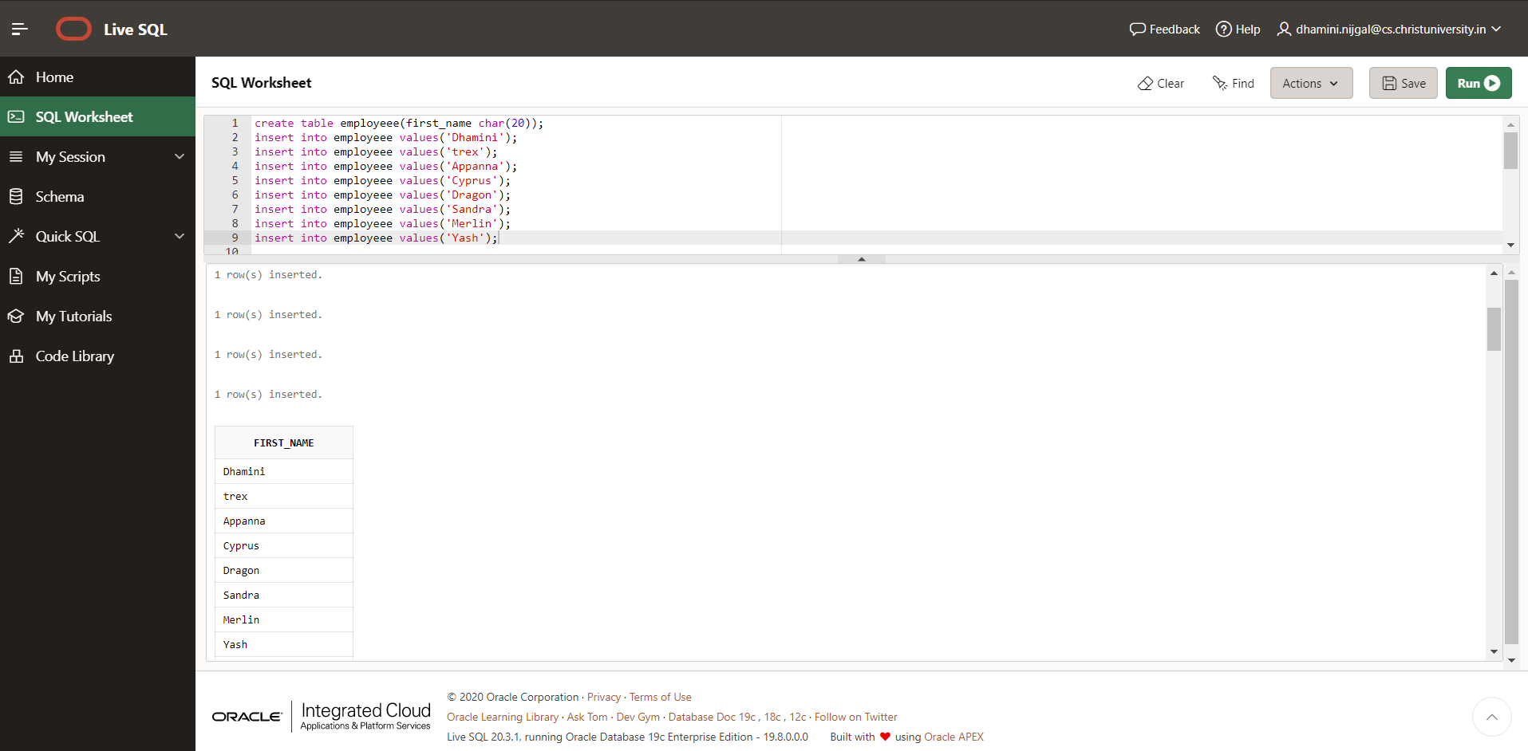

set serveroutput on

declare

firn varchar(25);

sb varchar(2);

cursor emp is

select first_name,substr(first_name,2,1) from employeee;

begin

dbms_output.put_line('first_name'||' '||'2nd Char'||' '||'ASCII');

for i in emp

loop

dbms_output.put_line(i.first_name||' '||substr(i.first_name,2,1)||' '||ascii(substr(i.first_name,2,1)));

end loop;

end;

/

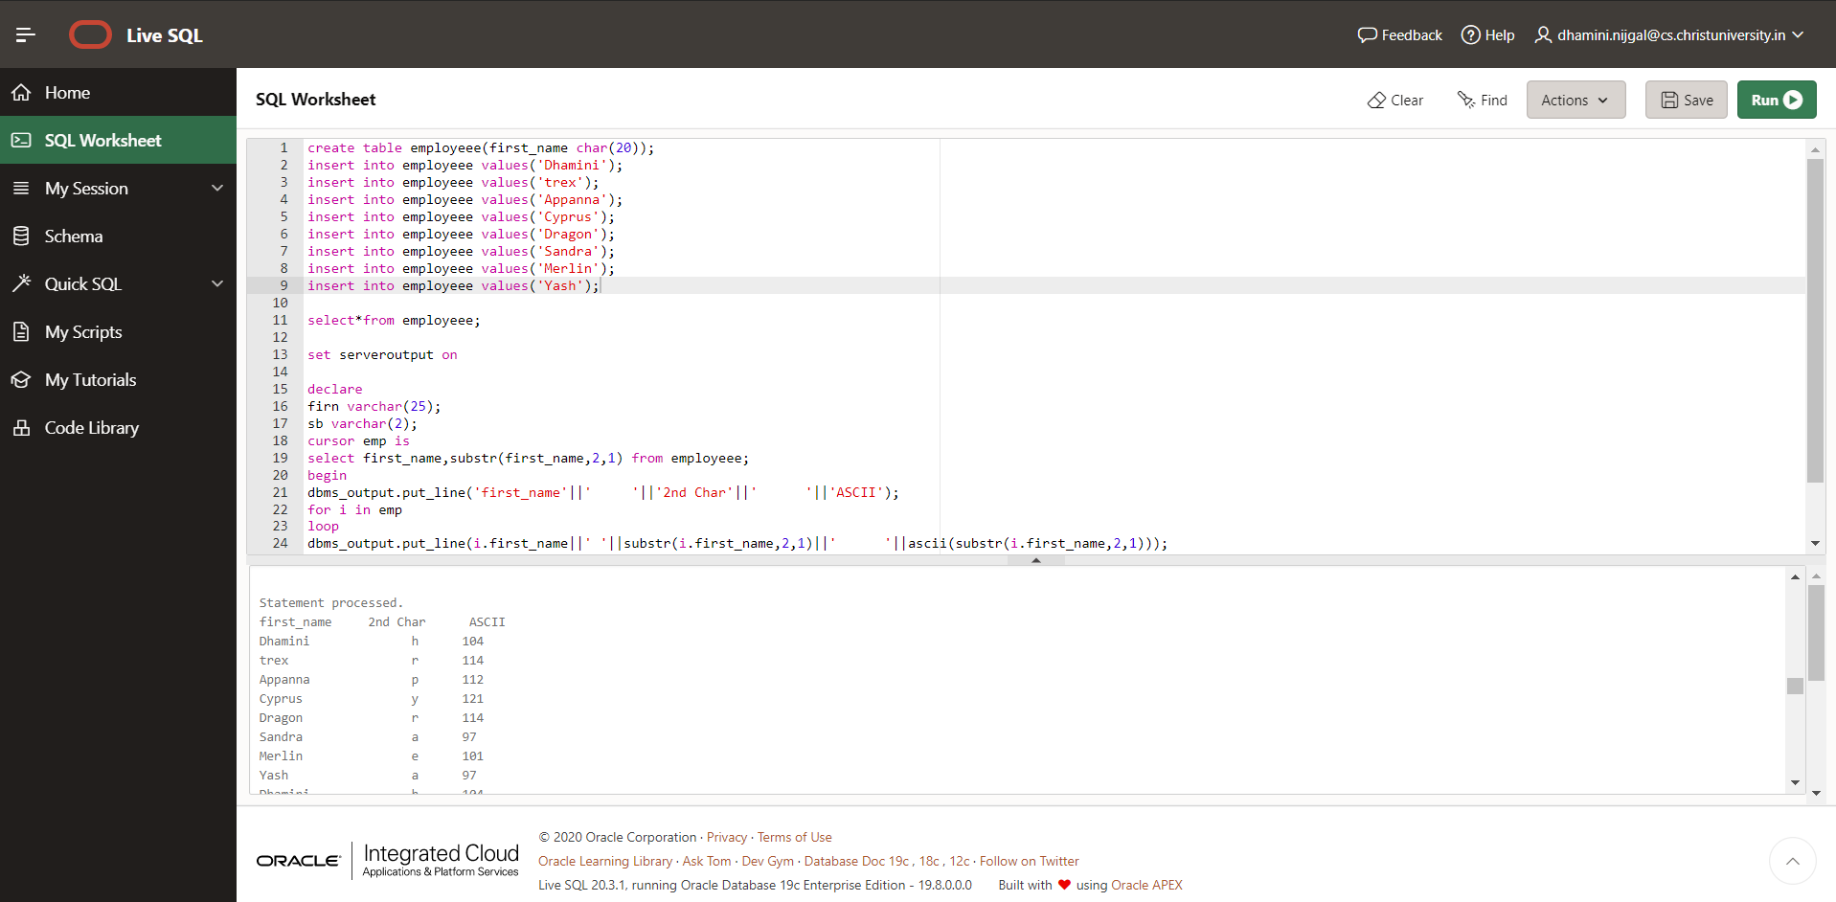

Statement processed.

first_name 2nd Char ASCII

Dhamini h 104

trex r 114

Appanna p 112

Cyprus y 121

Dragon r 114

Sandra a 97

Merlin e 101

Yash a 97

1. **Create tables : Student -- rollno, name, subject, marks, grade, city.**

**Card – grade (A, B, C, D, E), result.**

CREATE TABLE MARKS_CARD (GRADE VARCHAR(5),RESULT VARCHAR(20));

INSERT INTO MARKS_CARD VALUES('A','OUTSTANDING');

INSERT INTO MARKS_CARD VALUES('B','EXCELLENT');

INSERT INTO MARKS_CARD VALUES('C','DISTINCTION');

INSERT INTO MARKS_CARD VALUES('D','VERY GOOD');

INSERT INTO MARKS_CARD VALUES('E','AVERAGE');

CREATE TABLE STUDENT (ROLL_NO INT, NAME VARCHAR(50), SUBJECT VARCHAR(50),MARKS INT,GRADE VARCHAR(5),CITY VARCHAR(50));

INSERT INTO STUDENT VALUES(100,'DHAMINI','COMPUTER',50,'A','BANGALORE');

INSERT INTO STUDENT VALUES(101,'APPANNA','HISTORY',40,'B','CHENNAI');

INSERT INTO STUDENT VALUES(102,'JERIN','GEOGRAPHY',30,'C','KOLKATA');

INSERT INTO STUDENT VALUES(103,'ANITHA','MATH',20,'D','DELHI');

INSERT INTO STUDENT VALUES(104,'SANJU','ENGLISH',10,'E','KERALA');

OP:

1 row(s) inserted.

1 row(s) inserted.

1 row(s) inserted.

1 row(s) inserted.

1 row(s) inserted.

Table created.

1 row(s) inserted.

1 row(s) inserted.

1 row(s) inserted.

1 row(s) inserted.

1 row(s) inserted.

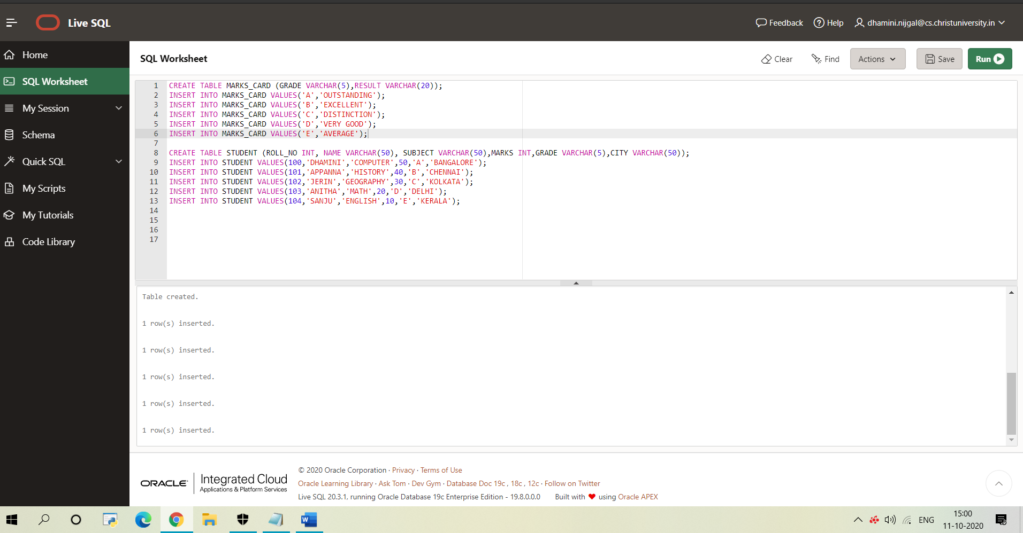

1. **Display the students who live in city where those students live whose grade is A.**

**ANSWER:**

select * from student where city in (select city from student where grade = 'A');

## Result Set 3

|  |  |  |  |  |  |
| --- | --- | --- | --- | --- | --- |
| **ROLL_NO** | **NAME** | **SUBJECT** | **MARKS** | **GRADE** | **CITY** |
| 100 | DHAMINI | COMPUTER | 50 | A | BANGALORE |
| 100 | DHAMINI | COMPUTER | 50 | A | BANGALORE |
| 100 | DHAMINI | COMPUTER | 50 | A | BANGALORE |

[Download CSV](https://livesql.oracle.com/apex/f?p=590:1:11064563180783::NO:::)

3 rows selected.

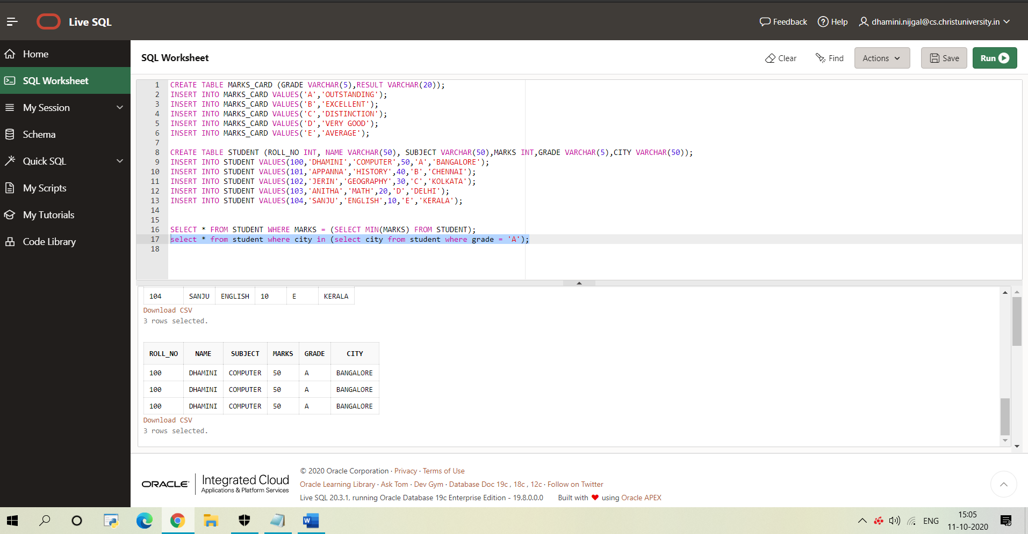

1. **Display the records where marks are equal to the minimum marks.**

**ANSWER:**

SELECT * FROM STUDENT WHERE MARKS = (SELECT MIN(MARKS) FROM STUDENT);

OP:

## Result Set 1

|  |  |  |  |  |  |
| --- | --- | --- | --- | --- | --- |
| **ROLL_NO** | **NAME** | **SUBJECT** | **MARKS** | **GRADE** | **CITY** |
| 104 | SANJU | ENGLISH | 10 | E | KERALA |
| 104 | SANJU | ENGLISH | 10 | E | KERALA |

[Download CSV](https://livesql.oracle.com/apex/f?p=590:1:11064563180783::NO:::)

2 rows selected.

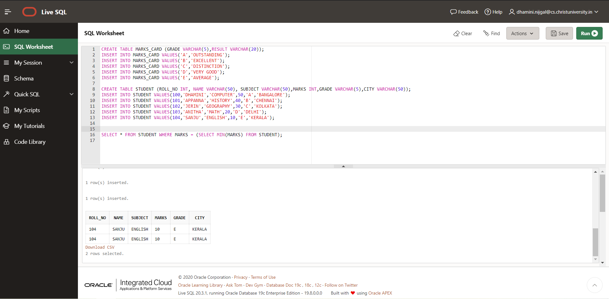

1. **Display all subjects having maximum marks less than avg of “accounts” subject.**

**Considering Geography instead of accounts**

select * from student where marks < (select avg(marks) from student where subject = 'GEOGRAPHY') and subject not in ('GEOGRAPHY');

## Result Set 12

|  |  |  |  |  |  |
| --- | --- | --- | --- | --- | --- |
| **ROLL_NO** | **NAME** | **SUBJECT** | **MARKS** | **GRADE** | **CITY** |
| 103 | ANITHA | MATH | 20 | D | DELHI |
| 104 | SANJU | ENGLISH | 10 | E | KERALA |
| 103 | ANITHA | MATH | 20 | D | DELHI |
| 104 | SANJU | ENGLISH | 10 | E | KERALA |
| 103 | ANITHA | MATH | 20 | D | DELHI |
| 104 | SANJU | ENGLISH | 10 | E | KERALA |
| 103 | ANITHA | MATH | 20 | D | DELHI |
| 104 | SANJU | ENGLISH | 10 | E | KERALA |
| 103 | ANITHA | MATH | 20 | D | DELHI |
| 104 | SANJU | ENGLISH | 10 | E | KERALA |
| 103 | ANITHA | MATH | 20 | D | DELHI |
| 104 | SANJU | ENGLISH | 10 | E | KERALA |
| 103 | ANITHA | MATH | 20 | D | DELHI |
| 104 | SANJU | ENGLISH | 10 | E | KERALA |
| 103 | ANITHA | MATH | 20 | D | DELHI |
| 104 | SANJU | ENGLISH | 10 | E | KERALA |
| 103 | ANITHA | MATH | 20 | D | DELHI |
| 104 | SANJU | ENGLISH | 10 | E | KERALA |
| 103 | ANITHA | MATH | 20 | D | DELHI |
| 104 | SANJU | ENGLISH | 10 | E | KERALA |

[Download CSV](https://livesql.oracle.com/apex/f?p=590:1:11064563180783::NO:::)

20 rows selected.

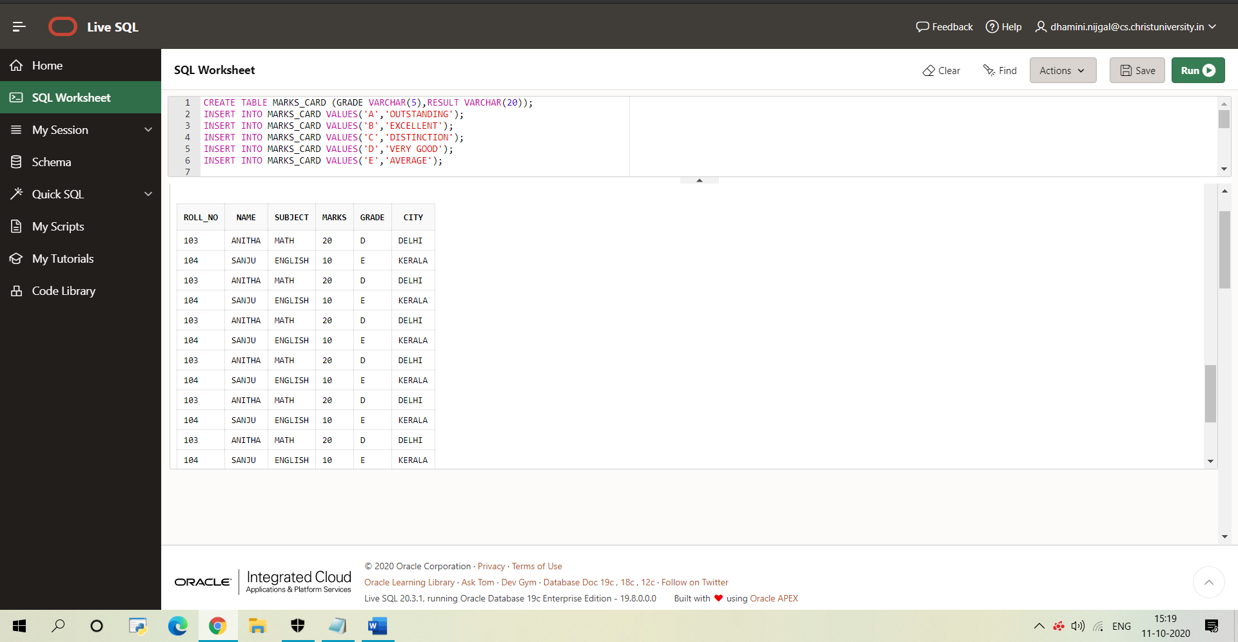

1. **List all the students who got ‘distinction’.**

## Result Set 28

|  |  |  |  |  |  |
| --- | --- | --- | --- | --- | --- |
| **ROLL_NO** | **NAME** | **SUBJECT** | **MARKS** | **GRADE** | **CITY** |
| 102 | JERIN | GEOGRAPHY | 30 | C | KOLKATA |

[Download CSV](https://livesql.oracle.com/apex/f?p=590:1:11064563180783::NO:::)

1 rows selected.

1. **Display the sum of marks of students who have got ‘first’ class in maths.**

SELECT SUM(MARKS) FROM STUDENT WHERE SUBJECT = 'MATH' AND GRADE = (SELECT RESULT FROM CARD WHERE GRADE ='C');

## Result Set 10

|  |
| --- |
| **SUM(MARKS)** |
| - |

[Download CSV](https://livesql.oracle.com/apex/f?p=590:1:11064563180783::NO:::)